SharePoint Tracking - Incoming Applications

Thursday, October 15, 2015

9:40 AM

The SharePoint [Application Tracking](https://go.dhss.ak.local/dsds/main/PQA/Lists/Application%20Tracking/AllItems.aspx) Log (<https://go.dhss.ak.local/dsds/main/PQA/Lists/Application%20Tracking/AllItems.aspx>) is found on the [Unit SharePoint Site](https://go.dhss.ak.local/dsds/main/PQA/SitePages/Home.aspx) (<https://go.dhss.ak.local/dsds/main/PQA/SitePages/Home.aspx>)

The [Tracker](https://go.dhss.ak.local/dsds/main/PQA/Lists/Application%20Tracking/AllItems.aspx) is used for Initial Applications, Recertifications and other changes that DS3 does not track such as time lines for processing. The process is the same for adding all application types. The tracker is very wide and can be expanded across both monitors, because of this some of the below diagrams may only show part of the screen or be in multiple pieces.

**View Options**

* + There are two views that can be used for entry of new applications or maintenance of in progress applications
  + **List Tools --> Items** to make the menu appear
  + **New Item** to get to the form for a new entry

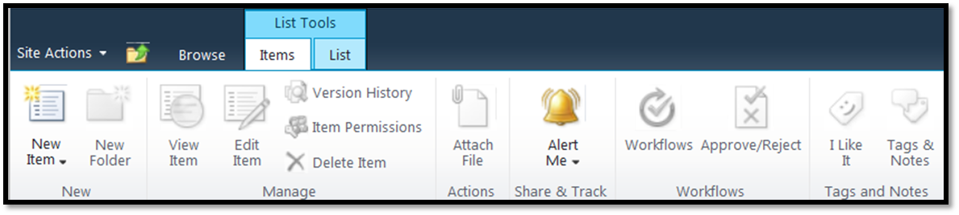

* + Spreadsheet style entry
  + **List Tools -->List--> Datasheet View** which gives a spreadsheet style view
  + From this view simply scroll to the bottom of the list for a new row or you can also edit the cells like a spreadsheet too.

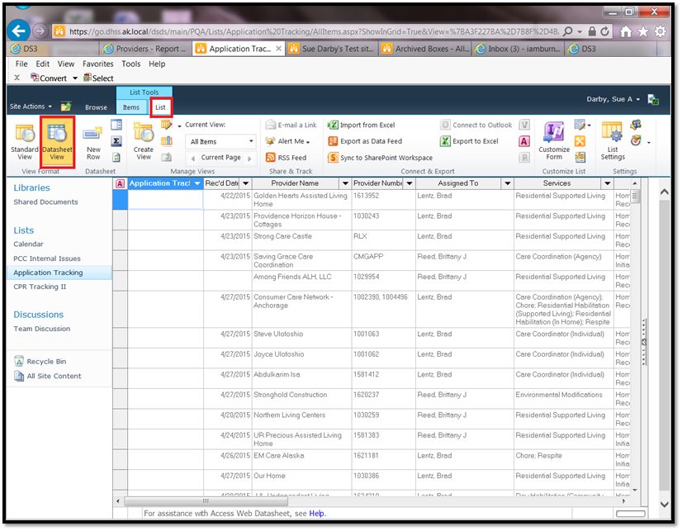

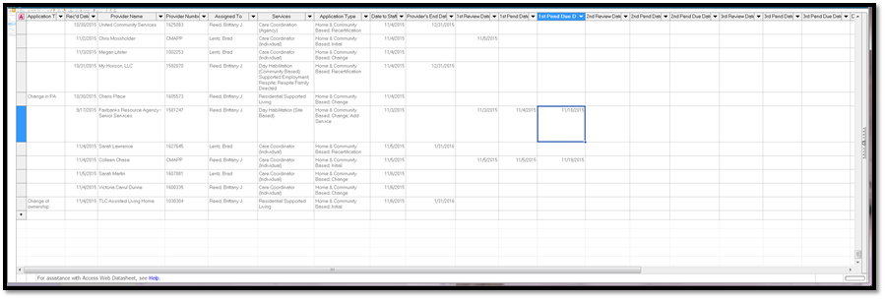

**Adding a New Provider in the Form View**

If you chose the form view:

* + Areas with a * are required
  + Enter the Provider Name
  + The Provider Number (if it is a recertification) or the CMGAPP, HCAPP etc for an initial
  + Choose Services

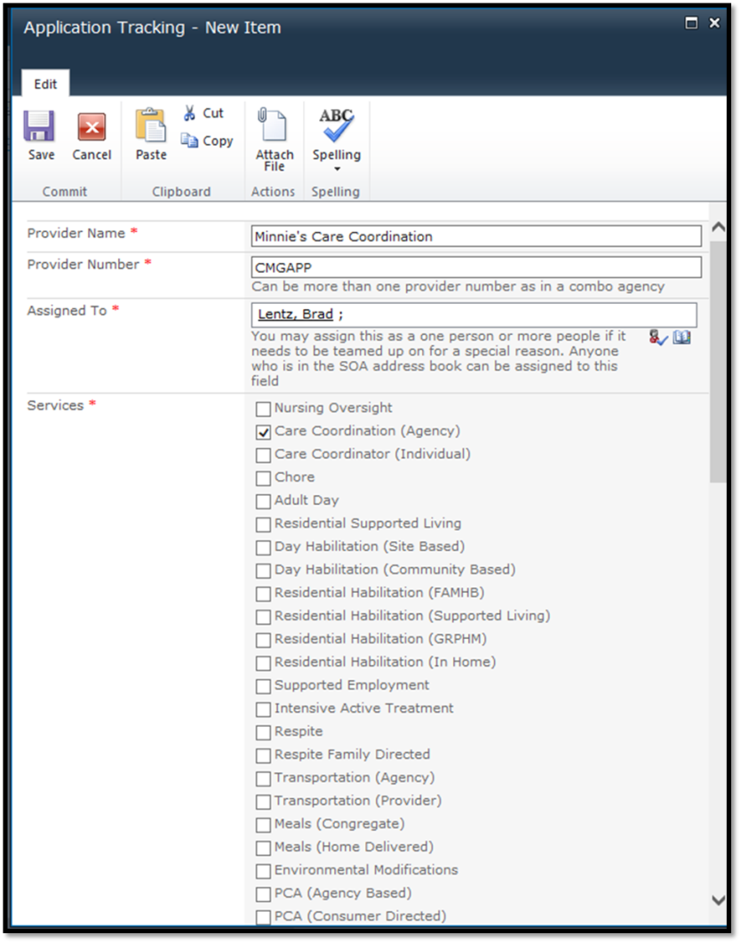

**Assigning to a worker**

* + IF you can spell the name exactly as it would be in the address book (non-case sensitive) you can simply type the name in the box in the main form and press enter. SP will either accept or give an error if you are wrong
  + Click the Open Book icon



* + and search for the person the application will be assigned to

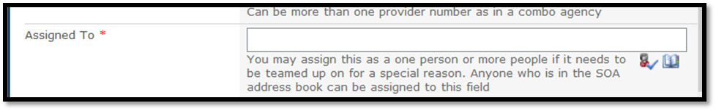

* + Search for the person
  + Add the person by double clicking on the result or clicking the Add Button
  + Click OK

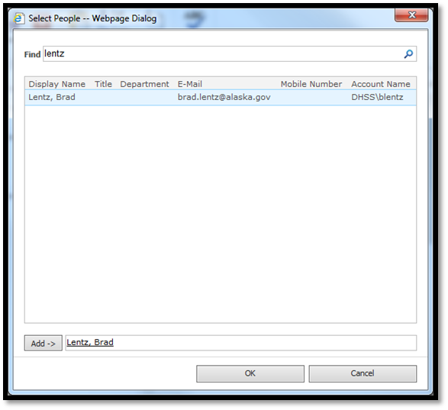

* + Check the appropriate boxes for the services the individual or agency provides
  + Check the boxes for the Application Type

**Dates**

* + Enter the Rec’d Date
  + Enter the Date to Staff
  + Enter the Provider’s End Date if it is a recertification

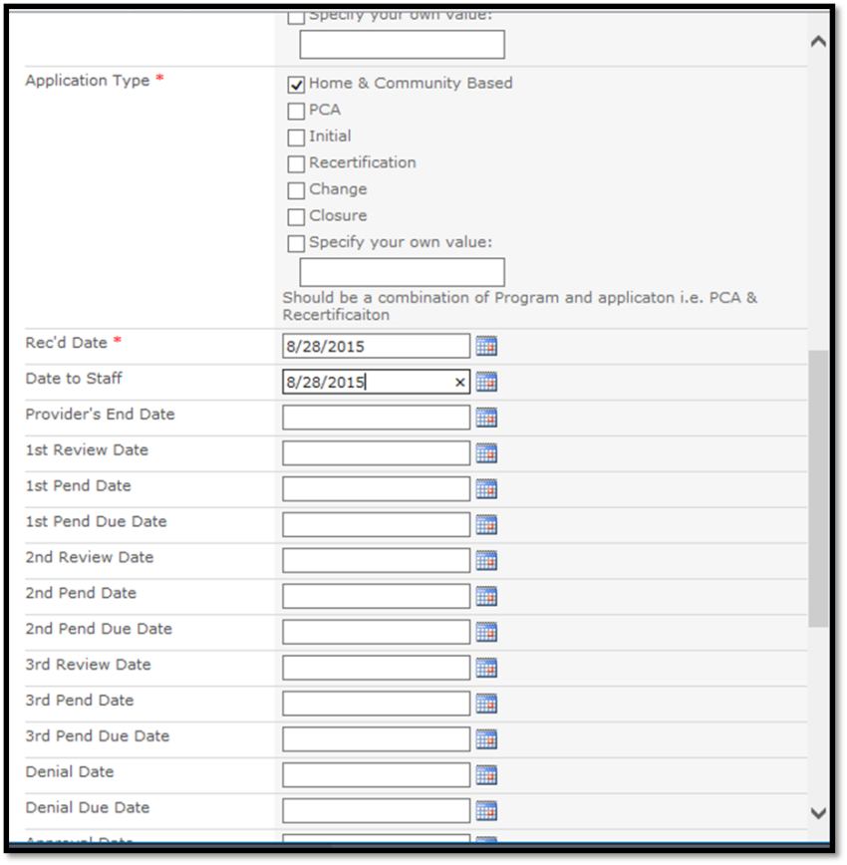

* + Add additional notes regarding the application that might be helpful to the reviewer such as actions going on with other units or a site review
  + If the application is for a new admin or other unique change that does not have a field above use the Application Tracking field otherwise ignore it
  + Add the date the entry is being created (used to track application start to end processing time)

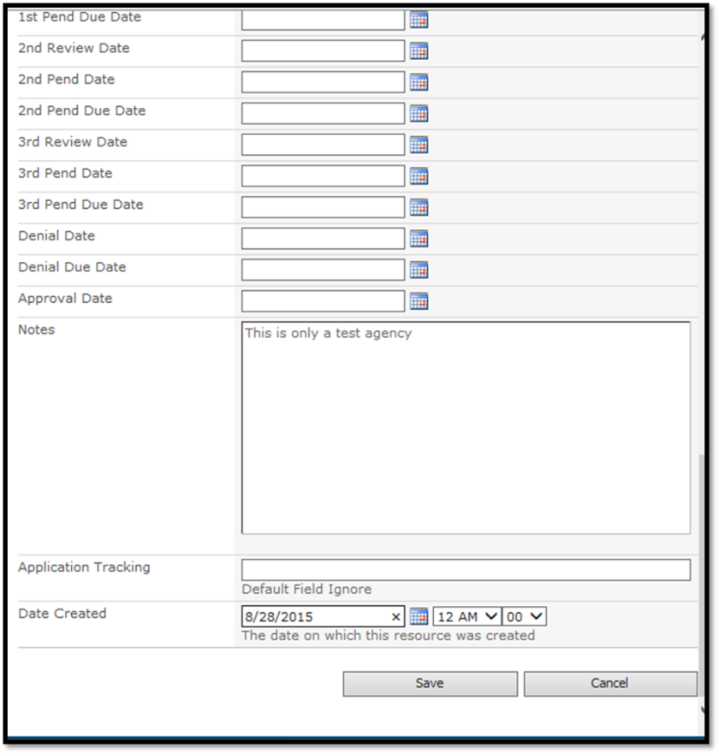

* + Save

**Final Results**

